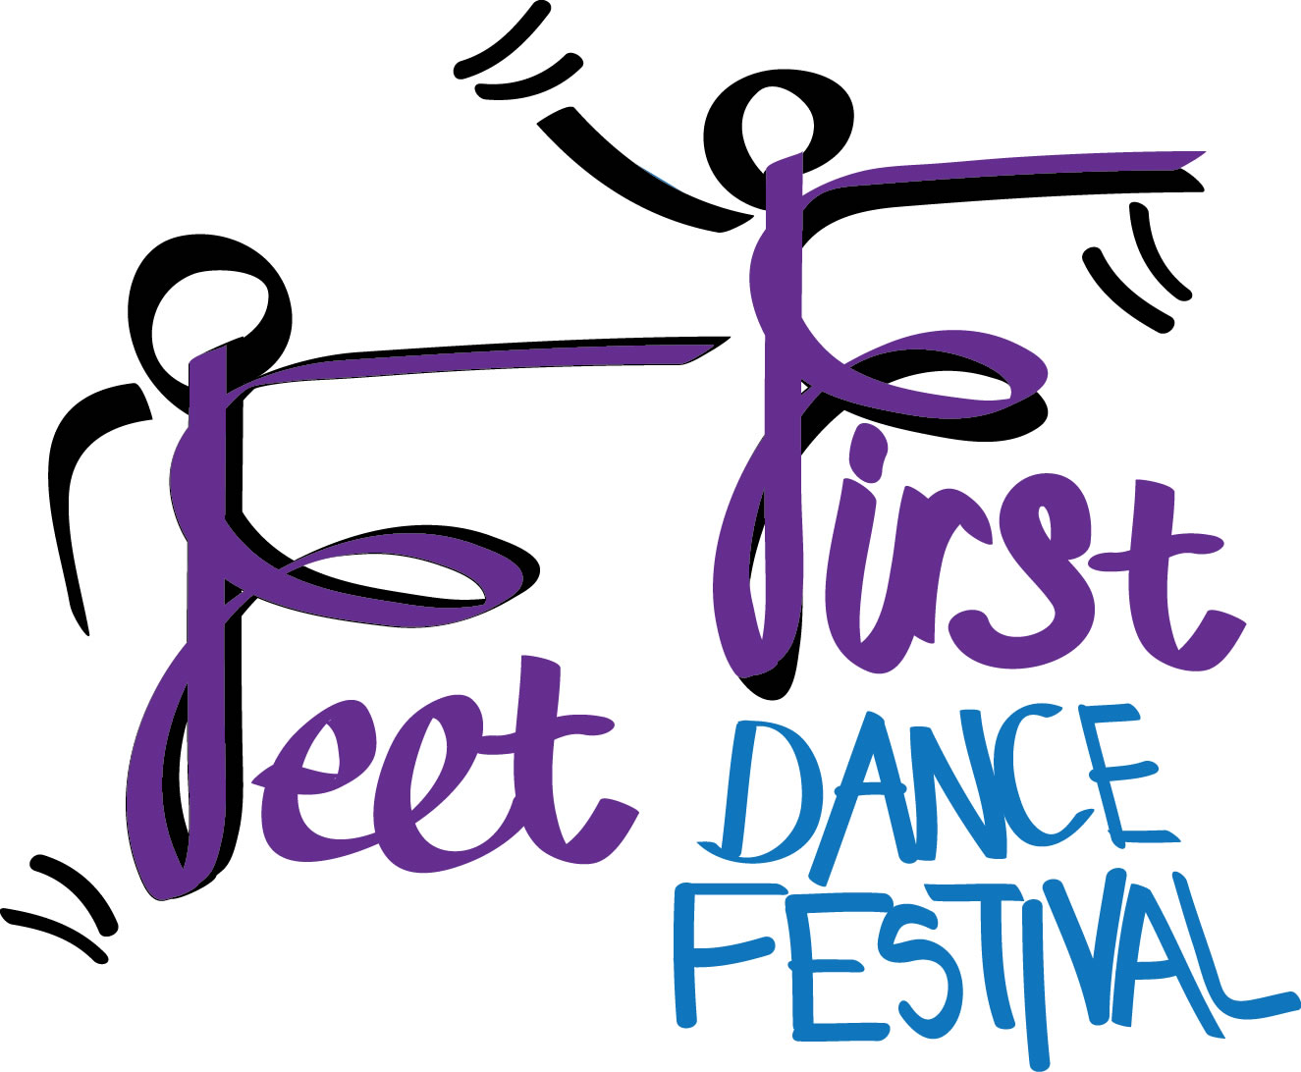
MERCHANDISE ORDER FORM
Child’s Name:
School:
Year Group:
Parent’s phone and email (in case we need to discuss your order):

Post direct by: Thursday, 6th February
To: E. Pooley, Move More, c/o All Saints Academy, Blaisdon Way, Cheltenham, GL51 0WH
Contact: Tel:01242711326
Email: emma@move-more.org

Choice of Payment: Cash _____ / Cheque _____ / BACS _____ (see below for details)

T-shirt Size Options: 5-6 years, 7-8 years, 9-11 years, Youth (approx. 12-13 years)

DESCRIPTION | SIZE | PRICE | QTY | TOTAL
T-Shirt – Black –Feet First logo |  | £8
T-Shirt – Mid Blue - Feet First logo |  | £8
T-Shirt – Light Pink - Feet First logo |  | £8
WATER BOTTLE – Move More logo | £4
KEYRING - Feet First logo | £1
TOTAL |  |  |  | £
Please ensure the correct amount is given- cheques payable to:
“Move More” (school is not responsible for your order, if correct amount is not given we will not be able to process your order.)
If paying by BACS:
Account Name: MOVE MORE
Account Number: 53647374
Sort Code: 20-98-68
Payment reference: Feet First (& child’s name)

